# **Single Cycle Datapath Questions**

## **F20: New Single Cycle Datapath Points: ___/20**

LC2K++ replaces the noop instruction in LC2K with the following new **I-type** instruction to help implement loops.

**binc regA regB offset**

binc’s execution semantics is as follows:

if (regA == regB) {

PC = PC + 1 + offset;

}

else {

PC = PC + 1;

regA++;

}

1. Write the equivalent LC2K assembly code for “binc 1 2 3”. You may use reg4 as a temporary register and you may add “.fill” into the data section. [2 pts]

Text Section

Data section

1. Modify the datapath to support binc and all the original LC2K instructions, except noop. You may use an **additional ALU2** and you can extend **two of the** **MUXes** with an **additional input**.

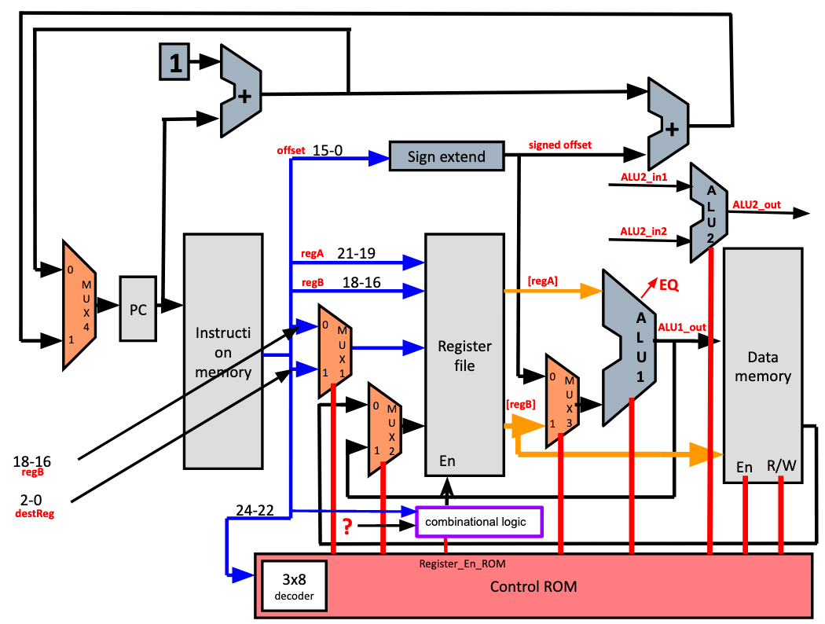

1. Specify the input wires to ALU2 in terms labels shown in the picture or a constant: [3 pts]

_________________

1. Specify the MUXes that are extended with additional inputs (MUX1, MUX2, MUX3, and/or MUX4), and the new input connected to them. Use the labels in the picture. [4 pts]

| Extended MUX# | New Input Wire Connected |
| --- | --- |
|  |  |
|  |  |

1. Determine the control signals for **binc** instruction that is stored in ROM.   
   Assume the **select signal** for any new MUX input is **‘10’**.   
   Register_En_ROM is given.   
   Control for ALU: add: 0; nor: 1 [4 pts]

| PC_en | MUX1 | MUX2 | MUX3 | Register_En_ROM | ALU1 | ALU2 | Data Mem_en | Data Mem_R/W |
| --- | --- | --- | --- | --- | --- | --- | --- | --- |
|  |  |  |  | **0** |  |  |  |  |

1. Describe the boolean equation for determining the following control signals for binc. Register_En_ROM is a control signal stored in ROM. [4 pts]

MUX4 select = { (opcode == beq) && EQ)} OR { _______________________ }

Register_En = Register_En_ROM OR { ________________________}  
 (This is the logic for combination logic box shown in picture)

1. Assume the following latencies. What is the minimum delay for binc instruction when regA is not equal to regB? [3 pts]

| Instruction Memory | 10ns | 15ns | 20ns |
| --- | --- | --- | --- |
| Register File Read | 5ns | 10ns | 10ns |
| ALU1 | 15ns | 15ns | 15ns |
| ALU2 | 15ns | 15ns | 15ns |
| Data Memory | 10ns | 20ns | 15ns |
| Register File Write | 15ns | 10ns | 10ns |
|  | Version 1 | Version 2 | Version 3 |

## **F19: The Mad Ladd [17 points]**

The mad genius Finbarr Calamitous, tired of writing multiple instructions to sequentially load and add, has designed a new instruction to replace noop:

**ladd = reg[destReg] = mem[regA] + mem[regB]**

Unfortunately, Calamitous has not completed his modifications to the datapath to accommodate his plans. To help him implement this new instruction, you will need to add exactly **one 2:1** mux (mux A) and **one 3:1** mux (mux B) to Calamitous’ schematics. Draw legibly. Note that the datapath section for branching is not shown to make the diagram easier to read. You may assume that part is unchanged. The add, lw, sw, and nor instructions must still be possible to implement.



1. Add the two MUXes to the diagram. Draw neatly and carefully. **[6]**
2. Using the original LC2K assembly language, write as short a code segment as possible that does the same thing as the instruction “**ladd 1 2 3**”. You can use reg4 as a temp register **[3]**

<Problem continued on next page>

c. Say that the data path changes caused the clock period to change from 8ns (original LC2K) to 9ns (above data path). Say Finbarr Calamitous has a program where 10% of the instructions are ladd instructions. That program takes exactly 1 second to run on the new data path. How long would it take to run on the original data path if you replaced the ladd instructions with original LC2K

instructions as you did in part b? Clearly show your work. **[8]**

### 

# **Multi-Cycle Datapath Questions**

## **W18: Multi-cycle datapath Points: ___/ 20**



Suppose we want to add support for pre- and post-incrementing load and store instructions to LC2K using the following format:

lw ++1 2 100 // pre-increment: R1 += 1 ; R2 = M[R1 + 100]

sw 1++ 2 100 // post-increment: M[R1+ 100] = R2; R1 += 1

1. Adding these instructions requires additional hardware. Add up to 2 additional wires on the above diagram to accomplish these instructions with the minimum number of additional cycles. (Do not modify the ALU, Memory, PC, ALU result, or Register File. Do not add any additional MUXes.) Circle the letter of any muxes you modify and describe what you are changing:

Changed mux(es): B F G I J

1. What operations occur in each cycle for a **pre-increment load word**? (Use the minimum number of cycles.)

| Cycle 1 | Fetch |
| --- | --- |
| Cycle 2 | Decode |
| Cycle 3 |  |
| Cycle 4 |  |
| Cycle 5 |  |
| Cycle 6 |  |
| Cycle 7 |  |
| Cycle 8 |  |

c. What operations occur in each cycle for a **post-increment store word**? (Use the

minimum number of cycles.)

| Cycle 1 | Fetch |
| --- | --- |
| Cycle 2 | Decode |
| Cycle 3 |  |
| Cycle 4 |  |
| Cycle 5 |  |
| Cycle 6 |  |
| Cycle 7 |  |
| Cycle 8 |  |

## **F18: Improving the Multicycle Datapath Points: ___/20** Imagine that we add a new LC2K instruction “madd”, with opcode value of 0b111 (replacing noop) with following functionality:

**Read memory at address [regA + offset] and increment regB by the value from memory. madd regA regB offset //regB = regB + Mem[regA + offset]**

Example: madd 1 2 10 //r2 = r2 + Mem[r1 + 10]

The “madd” instruction is an I-type instruction and will have the following machine code format:

a) Using the standard multi-cycle LC2K datapath shown above, make at most 2 additional

connections between the **labeled wires (labeled A–E)** and the inputs of the **labeled muxes (labeled M1,M2)** to implement the madd instruction.

**Fill in the blanks. If less than 2 connections are needed, then leave lines blank.**

Connect wire _____ with input of mux _____

Connect wire _____ with input of mux _____

b) Write the control signals for all the cycles needed to perform a “madd” operation on the modified multi-cycle datapath after your connections from part (a) have been added to the hardware.

Assumptions

● The top mux input is selected when all mux control bits are 0.

● All connections added to muxes have been added at the bottom of the mux. ● If a mux has multiple connections added to it from part (a), then the later alphabet wire will be at the bottom.

● The number of select bits for extended muxes might need to be increased ● MUX (dest): 0 selects regB and 1 selects destReg

● Mem (r/w): 0 for read and 1 for write.

● ALU (op): 0 for add and 1 for nor

**Hint:** If you’ve added more inputs to a mux, make sure the number of control bits for the modified mux is correct.

| **PC**  **(en)** | **MUX**  **(addr)** | **MEM**  **(en)** | **MEM**  **(r/w)** | **IR**  **(en)** | **MUX**  **(dest)** | **MUX**  **(rdata)** | **Reg**  **(write en)** | **MUX**  **(alu1)** | **MUX**  **(alu2)** | **ALU**  **(op)** |
| --- | --- | --- | --- | --- | --- | --- | --- | --- | --- | --- |
| 0 | 0 | 1 | 0 | 1 | X | X | 0 | 0 | 01 | 0 |
| 1 | X | 0 | X | 0 | X | X | 0 | X | XX | X |
|  |  |  |  |  |  |  |  |  |  |  |
|  |  |  |  |  |  |  |  |  |  |  |
|  |  |  |  |  |  |  |  |  |  |  |
|  |  |  |  |  |  |  |  |  |  |  |
|  |  |  |  |  |  |  |  |  |  |  |

## **W20: The Negator Points: ___/25**

A mysterious villain has appeared--going only by the name “The Negator”. The goal of this mystery figure is to flip the sign of all the values currently in memory. His first step will be to load the value he wants to change into a register. However, to finish the task, he will need a new instruction. The new instruction, **neg,** is defined as follows:

**neg regB offset // mem[offset] = -regB**

Read the value of regB and store **negative** regB into the memory address offset.

Example: neg 2 4 // mem[4] = -r2

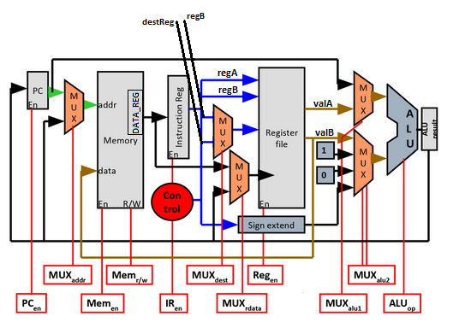

To support this new instruction, The Negator has to modify the above multicycle datapath

**(a)** To support **neg** instruction, you can **only modify the MUXes** (and add any necessary connections to them) **in the table below** and **add only *one new MUX***. Note that none of the MUXes should have more than four inputs to them. Describe your changes to datapath below. Note neg takes 5 cycles to complete in the new datapath.

| **MUX name** | **Modified (Yes/ No)** | **Connections added/removed** |
| --- | --- | --- |
| MUX_addr |  |  |
| MUX_dest |  |  |
| MUX_rdata |  |  |
| MUX_alu1 |  |  |
| NEW_MUX | Added New |  |

**(b)** Write the control signals for all the cycles needed for the “neg” instruction on the modified datapath after your connections have been added.

You can assume the following things:

● The top mux input is selected when all mux control bits are 0

● All connections added to any mux are added at the bottom of the mux

● The select bits for extended muxes may need to be increased from the original mux

● Mem (r/w): 0 for read, 1 for write

● ALU (op): 0 for add and 1 for nor

***Hint****.* ***If you've added more inputs to the MUX, make sure the number of control bits for the modified mux is correct***

| **PC**  **(en)** | **MUX**  **(addr)** | **MEM**  **(en)** | **MEM**  **(r/w)** | **IR (en)** | **MUX**  **(dest)** | **MUX**  **(rdata)** | **Reg**  **(write en)** | **MUX**  **(alu1)** | **MUX**  **(alu2)** | **ALU**  **(op)** | **NEW_**  **MUX** |
| --- | --- | --- | --- | --- | --- | --- | --- | --- | --- | --- | --- |
| 0 | 0 | 1 | 0 | 1 | X | X | 0 | 0 | 01 | 0 | X |
| 1 | X | 0 | X | 0 | X | X | 0 | X | XX | X | X |
|  |  |  |  |  |  |  |  |  |  |  |  |
|  |  |  |  |  |  |  |  |  |  |  |  |
|  |  |  |  |  |  |  |  |  |  |  |  |
|  |  |  |  |  |  |  |  |  |  |  |  |
|  |  |  |  |  |  |  |  |  |  |  |  |

## **F20: Multicycle Datapath Design Points: ___/20**

Consider a new LC2K I-type swap instruction:

**swp regA regB offset**

Execution semantics of this instruction is as follows:

tmp = Mem[regA+ offset]

Mem[regA + offset] = regB

regB = tmp



1. Implement **swp** in the multi-cycle data-path in five or fewer cycles. Specify the operations for **swp** in each cycle. Provide an informal description (few words) followed by exact changes to the multicycle state. Assume [data_reg] stores the value read from memory. [10 pts]

*You may not need to fill all the blanks.*

Cycle 1: Fetch

[Instruction_Reg] = Mem[PC]

[ALU_Result] = PC + 1

Cycle 2: Decode

[PC] = [ALU_Result]

Read register values

Cycle 3:

___________ = _______________

___________ = _______________

Cycle 4:

___________ = _______________

___________ = _______________

Cycle 5:

___________ = _______________

___________ = _______________

1. Specify the control signals for each cycle for **swp**: [10 pts]

| Cycle | PC (en) | MUX (addr) | MEM (en) | MEM (r/w) | IR (en) | MUX (dest) | MUX (rdata) | Reg (en) | MUX (alu1) | MUX (alu2) | ALU (op)  0: add  1: nor |
| --- | --- | --- | --- | --- | --- | --- | --- | --- | --- | --- | --- |
| 1 | 0 | 0 | 1 | 0 | 1 | X | X | 0 | 0 | 01 | 0 |
| 2 | 1 | X | 0 | X | 0 | X | X | 0 | X | XX | X |
| 3 |  |  |  |  |  |  |  |  |  |  |  |
| 4 |  |  |  |  |  |  |  |  |  |  |  |
| 5 |  |  |  |  |  |  |  |  |  |  |  |

## **W21 Multi-cycle Datapath Design Points: ___/20**

Consider a new LC2K I-type instruction:

**accmems regA regB stride**

The goal of this instruction is to facilitate strided accumulation of the data in the memory. Execution semantics of this instruction is as follows:

**regB = regB + Mem[regA];**

**regA = regA + stride;**



a) You have been asked to change the LC2K multi-cycle datapath to support the new instruction. We can **only modify the MUXes** (and add any necessary connections to them). Note that none of the MUXes should have more than four inputs to them. Describe your changes to datapath below. (accmems **should take 5 cycles or less** to complete) (5pts)

Example:

MUX_example1: MUX_example2:  
 DATA_REG added to input 10. NA // Leave blank or type NA if unchanged.

* MUX_addr: MUX_dest:

_____________________ ____________________

* MUX_rdata: MUX_alu1:

_____________________ ____________________

* MUX_alu2

_____________________

b) Implement accmems in the multi-cycle data-path in five or fewer cycles. Specify the operations for each cycle. Provide an informal description (few words) followed by exact changes to the multicycle state. Assume [data_reg] stores the value read from memory. (10 pts)

*You may not need to fill all the blanks.*

Cycle 1: Fetch

[Instruction_Reg] = Mem[PC]

[ALU_Result] = PC + 1

Cycle 2: Decode

[PC] = [ALU_Result]

Read register values

Cycle 3:

________________ = ____________________

________________ = ____________________

Cycle 4:

________________ = ____________________

________________ = ____________________

Cycle5:

________________ = ____________________

________________ = ____________________

c) Write the control signals for all the cycles needed for the “accmems” instruction on the modified datapath after your connections have been added. (5 pts)

You can assume the following things:

* All connections added to any mux are added at the bottom of the mux
* The select bits for extended muxes may need to be increased from the original mux

| **PC**  **(en)** | **MUX**  **(addr)** | **MEM**  **(en)** | **MEM**  **(r/w)** | **IR (en)** | **MUX**  **(dest)** | **MUX**  **(rdata)** | **Reg**  **(write en)** | **MUX (alu1)** | **MUX (alu2)** | **ALU (op)** |
| --- | --- | --- | --- | --- | --- | --- | --- | --- | --- | --- |
| 0 | 0 | 1 | 0 | 1 | X | X | 0 | 0 | 01 | 0 |
| 1 | X | 0 | X | 0 | X | X | 0 | X | XX | X |
|  |  |  |  |  |  |  |  |  |  |  |
|  |  |  |  |  |  |  |  |  |  |  |
|  |  |  |  |  |  |  |  |  |  |  |
|  |  |  |  |  |  |  |  |  |  |  |
|  |  |  |  |  |  |  |  |  |  |  |